USER MANUAL

BOGAZICI WEB ANNOTATION TOOL

Bogaziçi Web Annotation Tool is a annotation tool for web pages that is compatible with W3C Web Annotation standard.

BOGAZICI WEB ANNOTATION TOOL

USER MANUAL

DEVELOPERS

Özlem AKBAŞ  
Sarah BEIRKDAR  
Uğur HİÇYILMAM

# WELCOME

This document is the user manual for the Boğaziçi Web Annotation Tool that created for Boğaziçi University Software Engineering SWE 574 Fall 2016 class.

# How to LOGIN APPLICATION ANNOTATION

After you completed installation of the extension, click the extension button that presented on the top right of the browser.

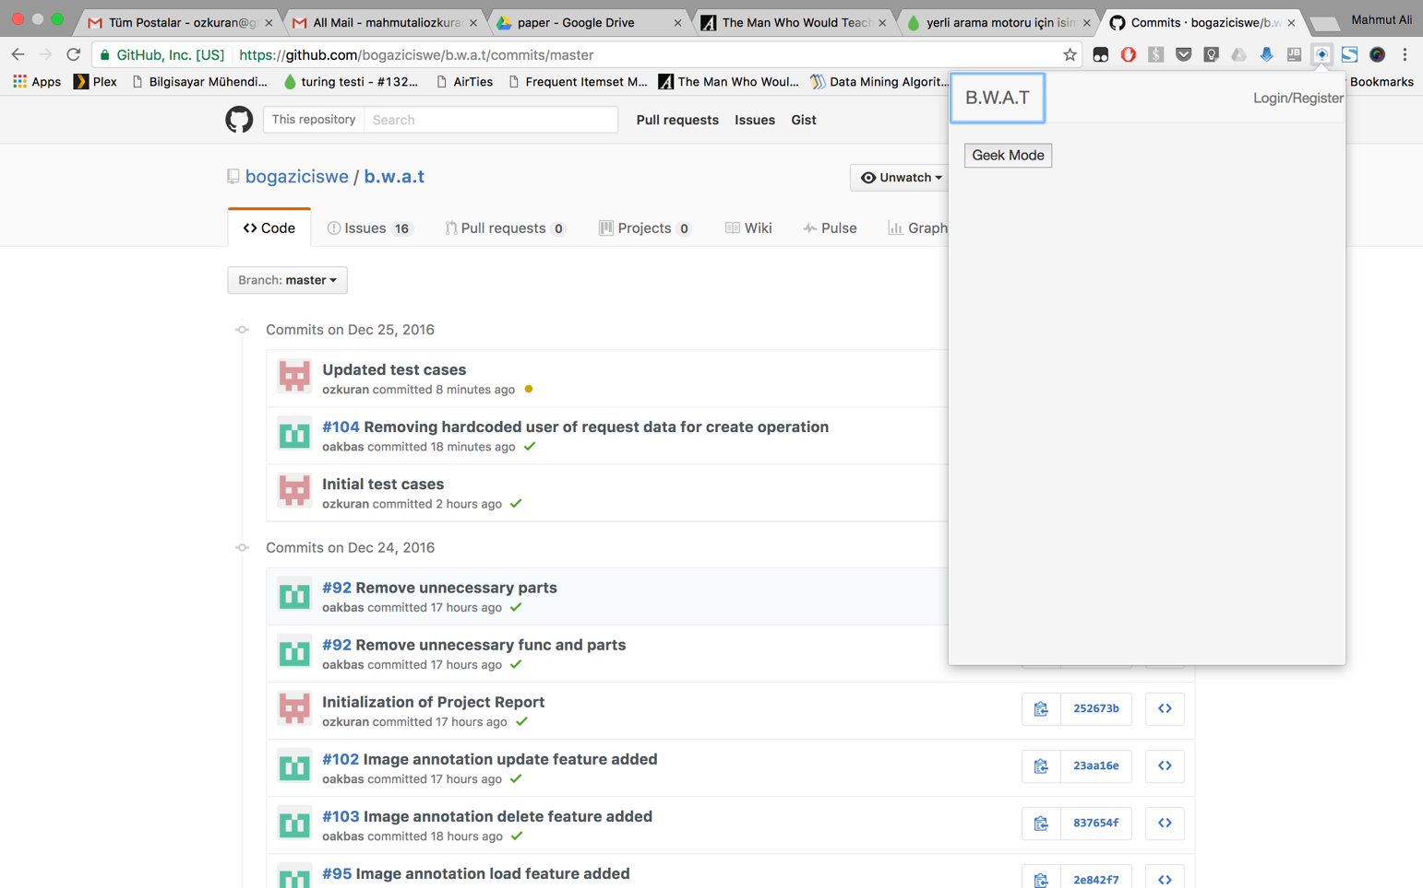

Click login register button on top right of the extension window. The login window will be appeared.

### 

Enter you user name and password.

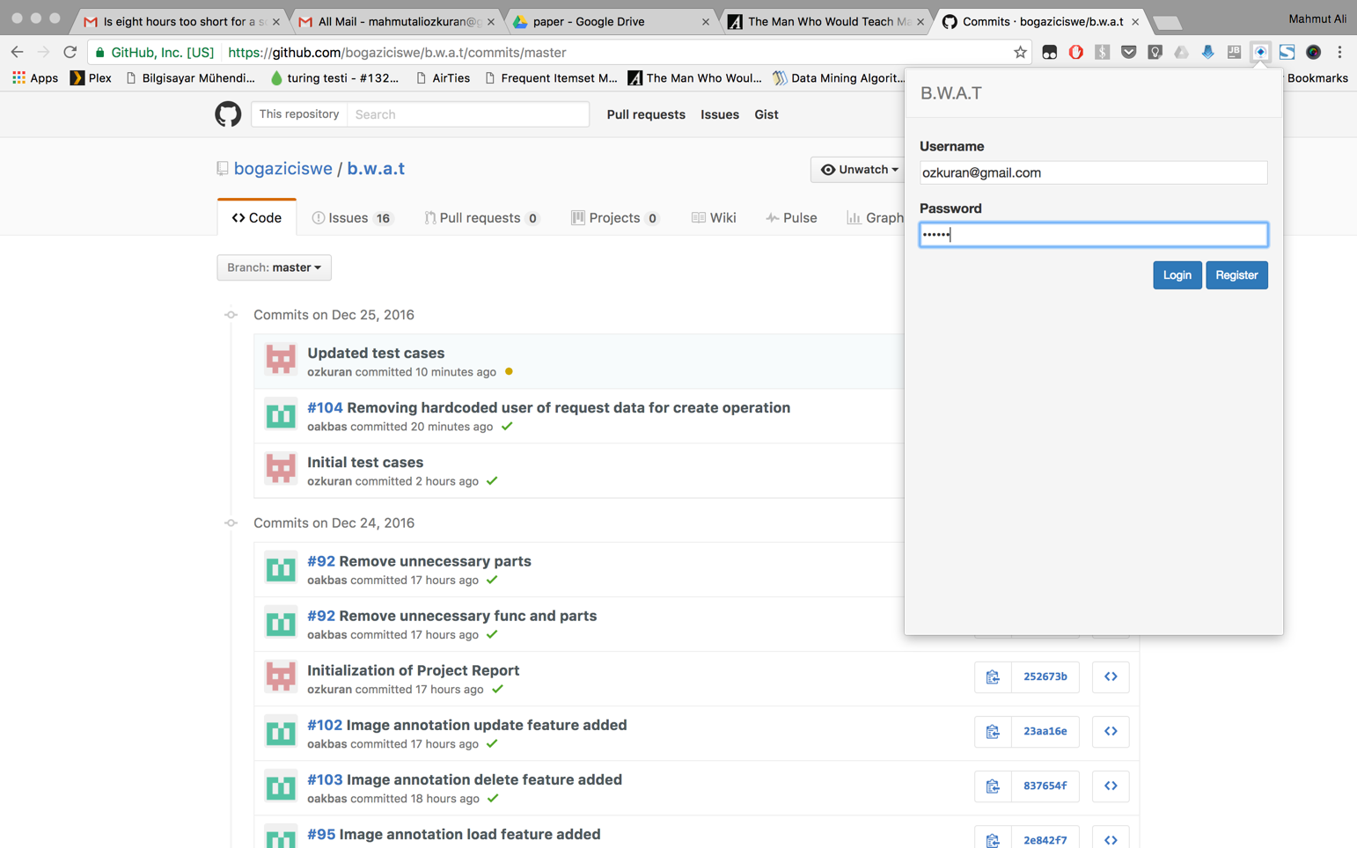

Press login button and you are in.

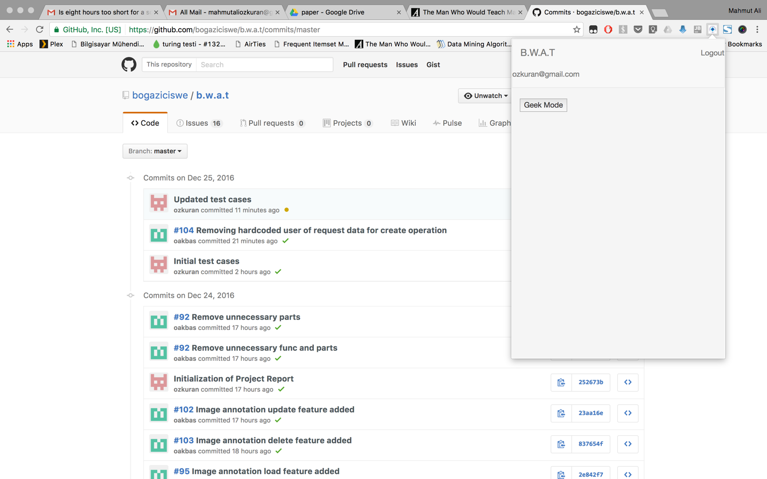

# How to ANNOTATE TEXT

Surf to the page that you want to annotate.



Select the text you want to be annotate the annotation will be appeared.

### 

Click the annotate button and write your thoughts.

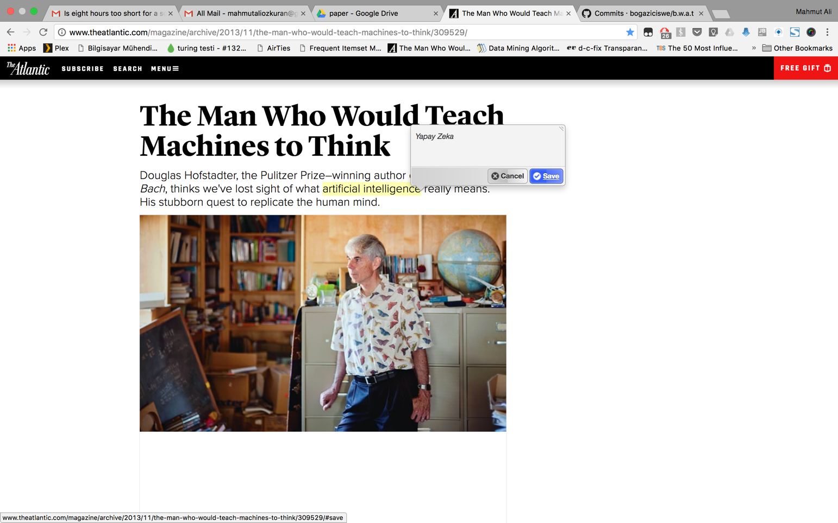

State your motivation about the annotation.

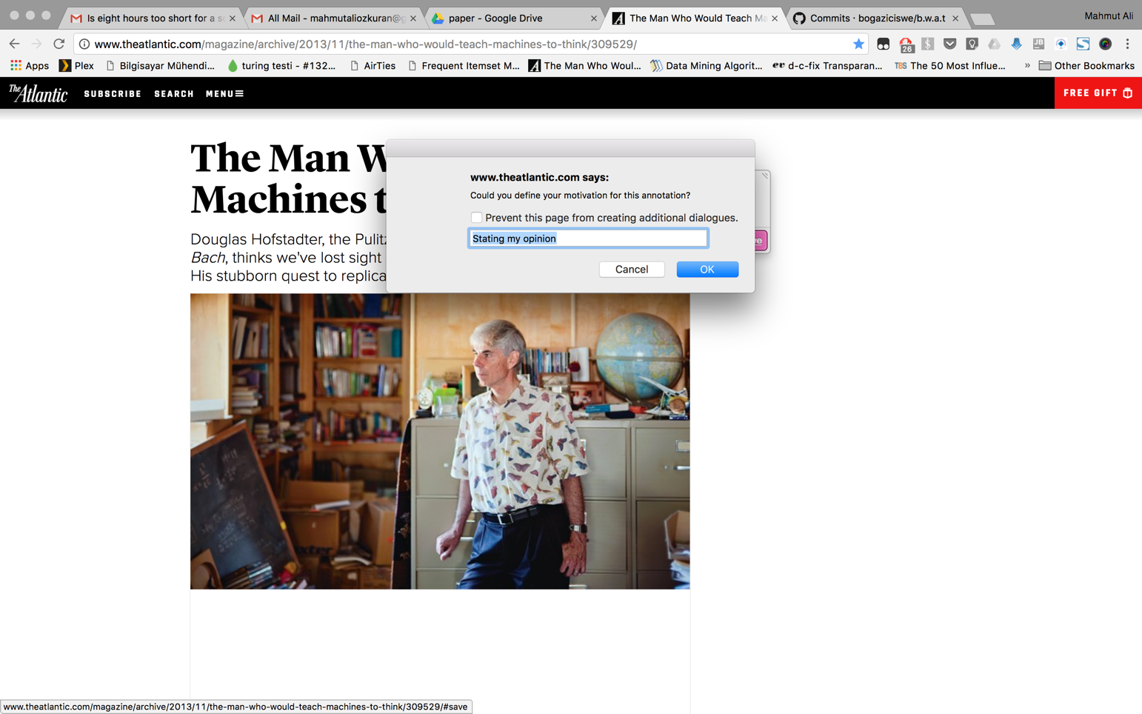

Press ok and your annotation has been saved.

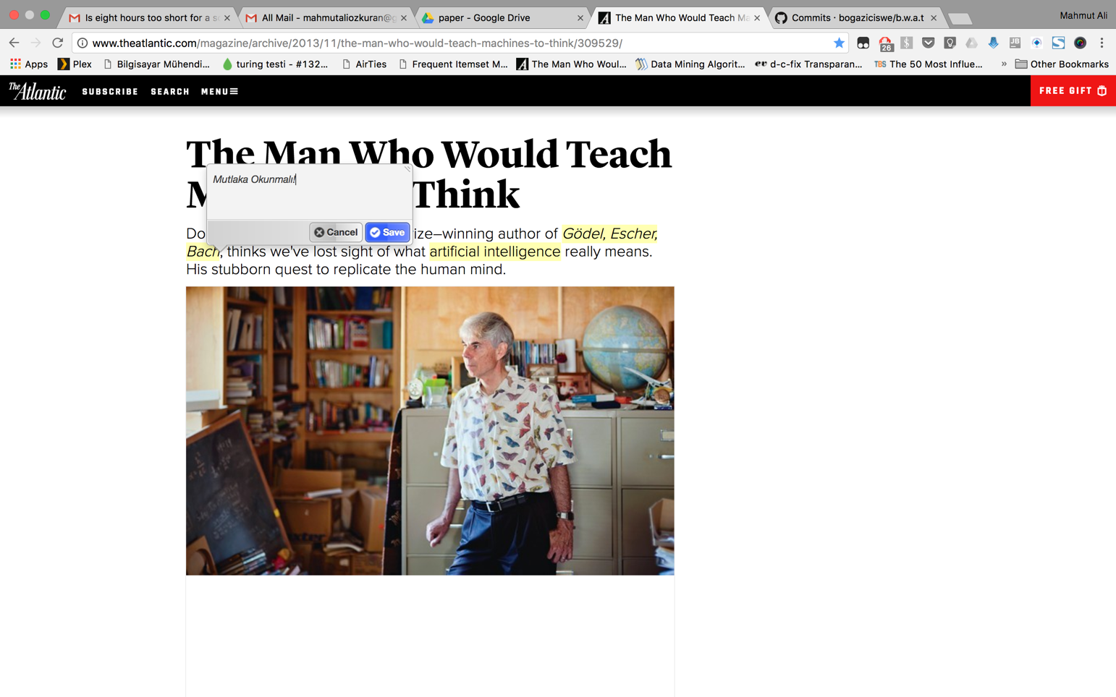

# 

# How to ACTIVATE GEEK MODE

Surf to the page that your annotations present and click to the extension button and open extension window.

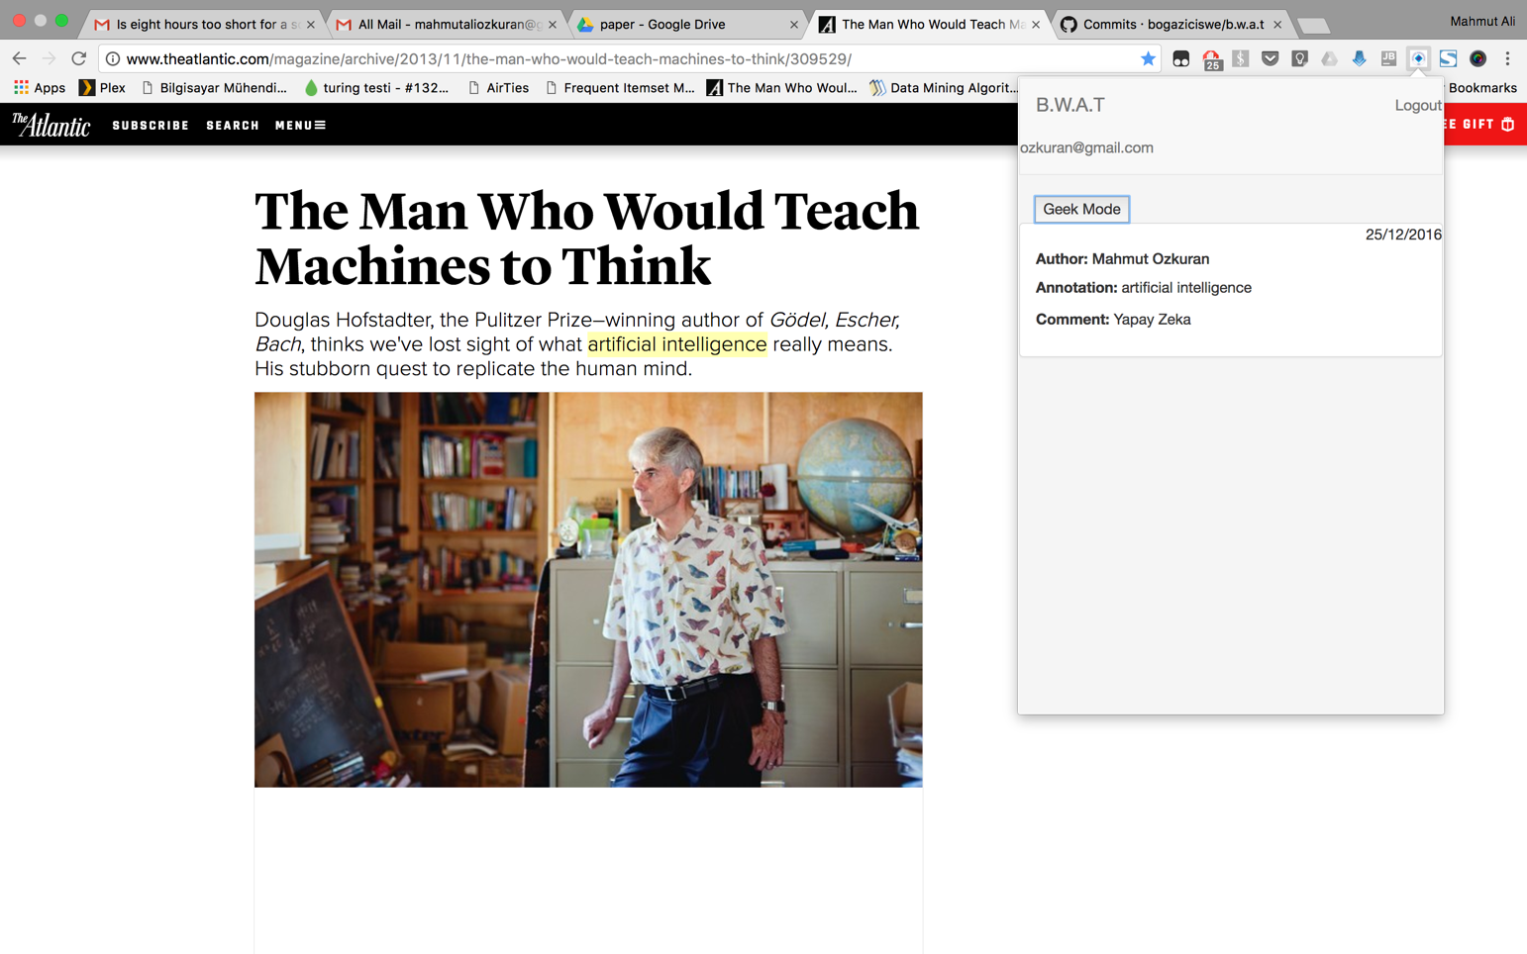

Press the “Geek Mode” button and see enable the Geek Mode and see the JSON of the selected annotation.

### 

# How to ANNOTATE IMAGE

Surf to the page that you want to annotate. Select the part of the image you want to annotate.

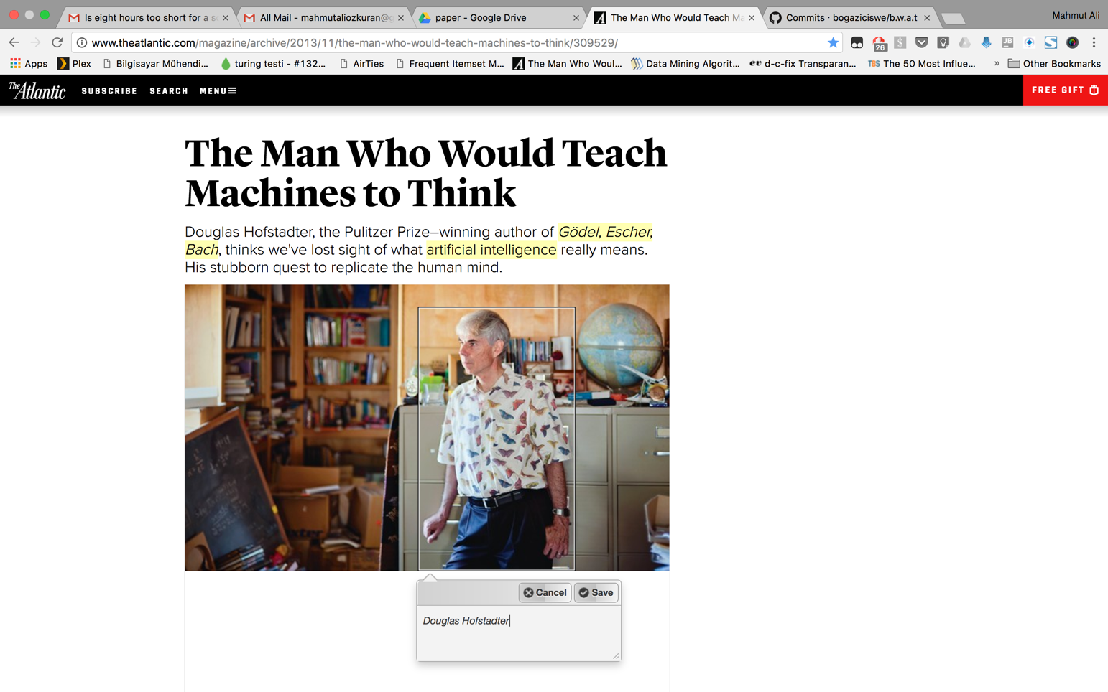

Write your thoughts and state your motivation about the annotation.



Press ok and your annotation has been saved.

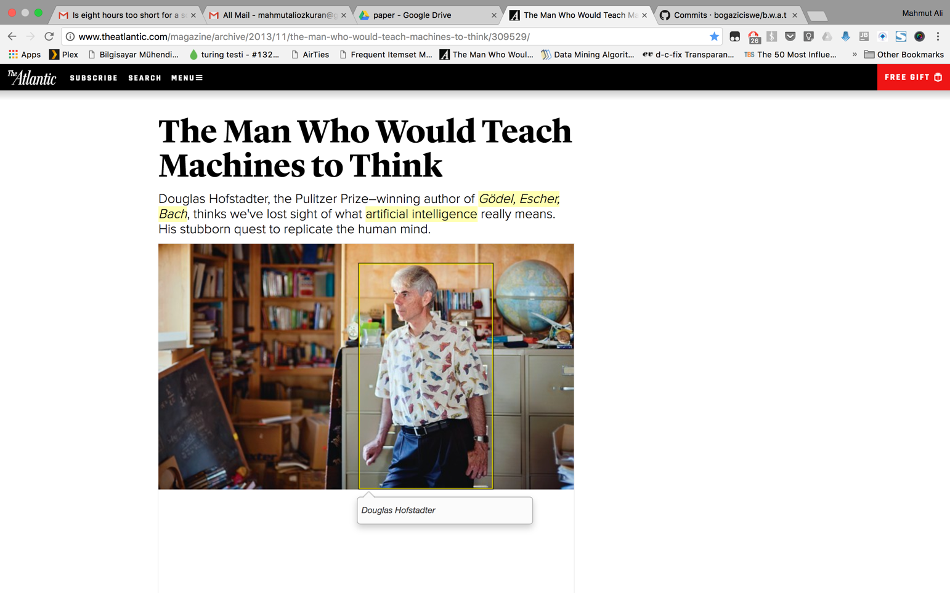

# How to EDIT TEXT ANNOTATION

Surf to the page the annotation that you want edit is present. Get over the annotation and get annotation to be displayed.

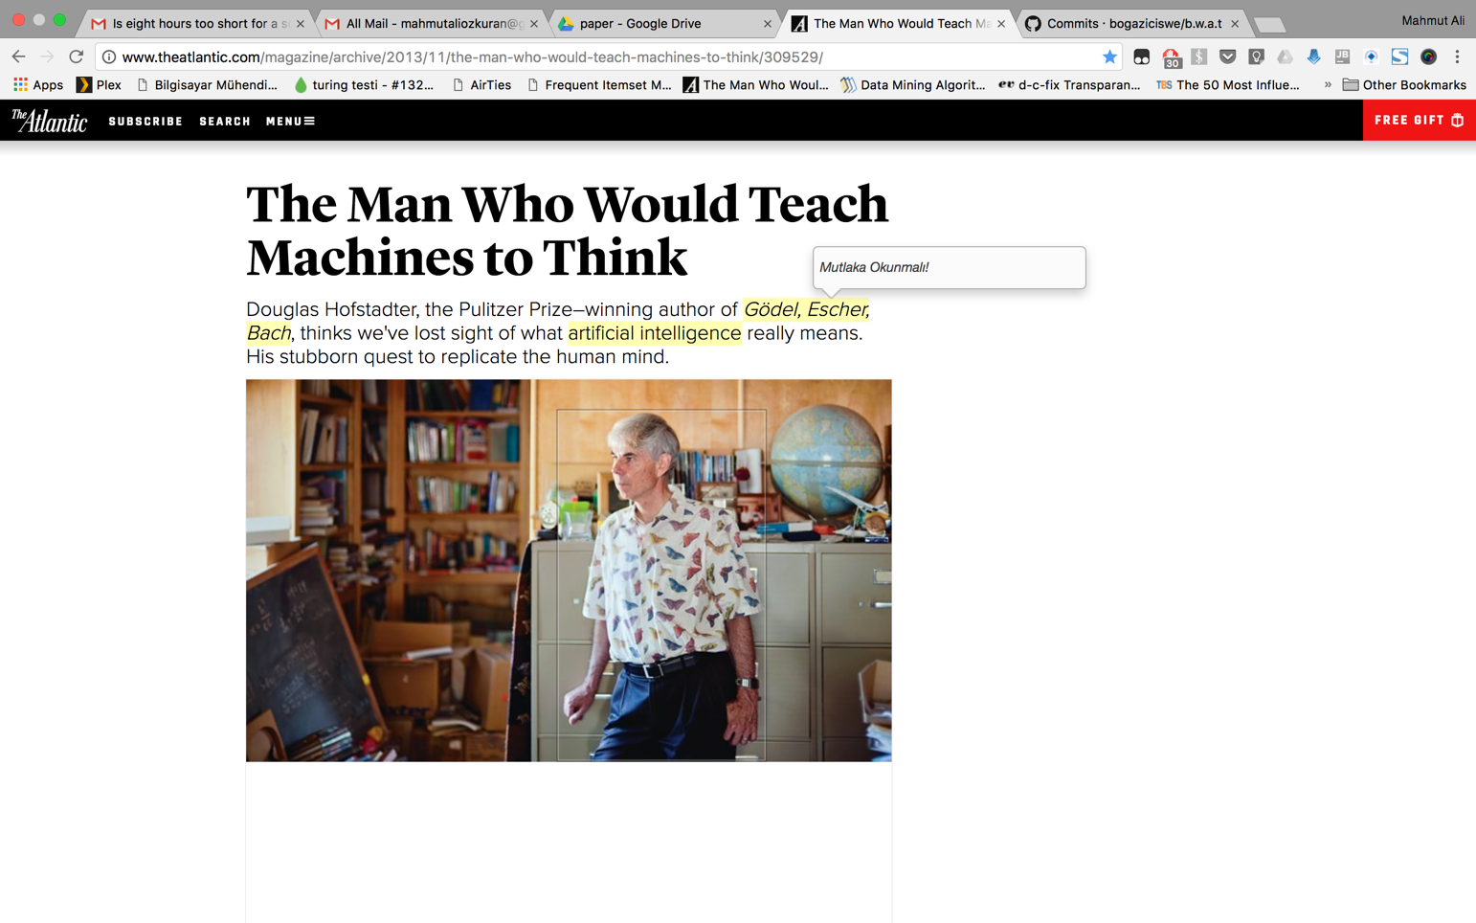

Press the pencil button to edit the annotation. Make your changes and press “Save” button to make your changes permanent.

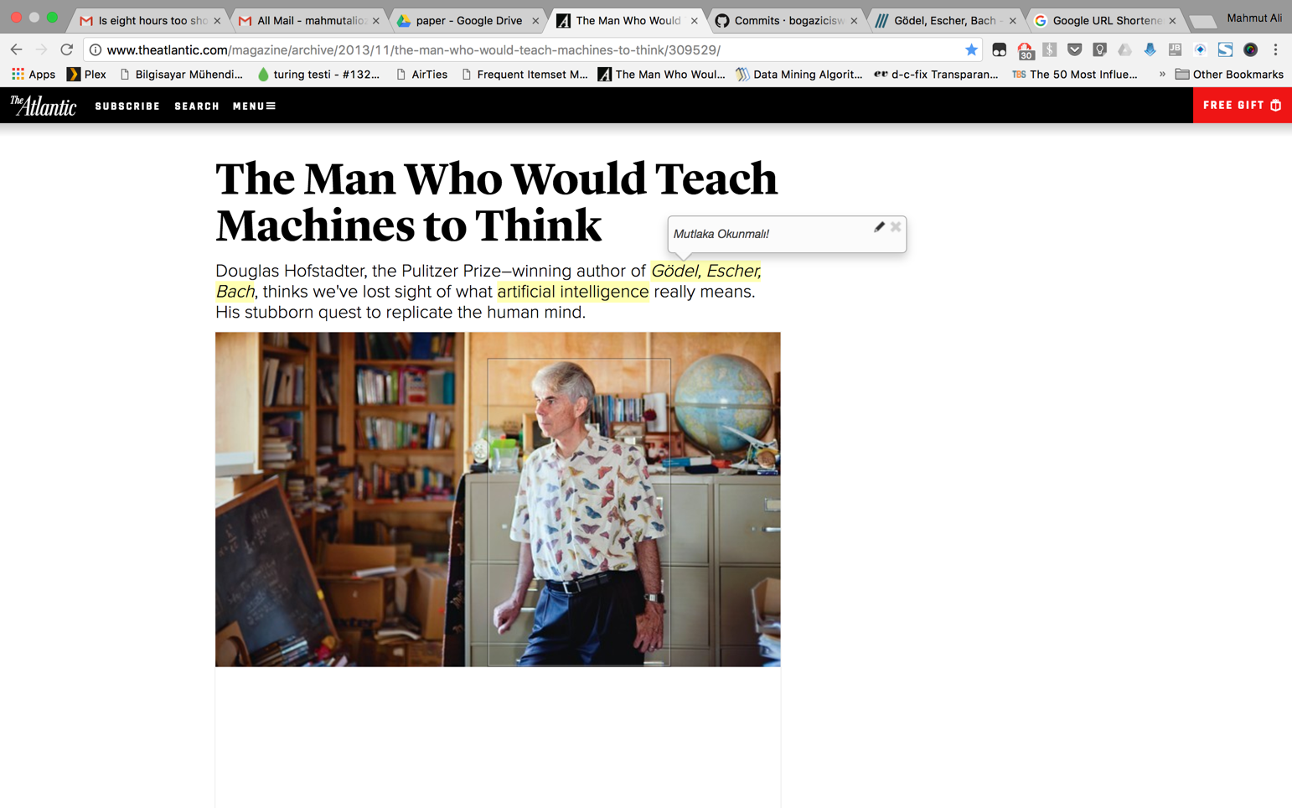

And your annotation has been edited.

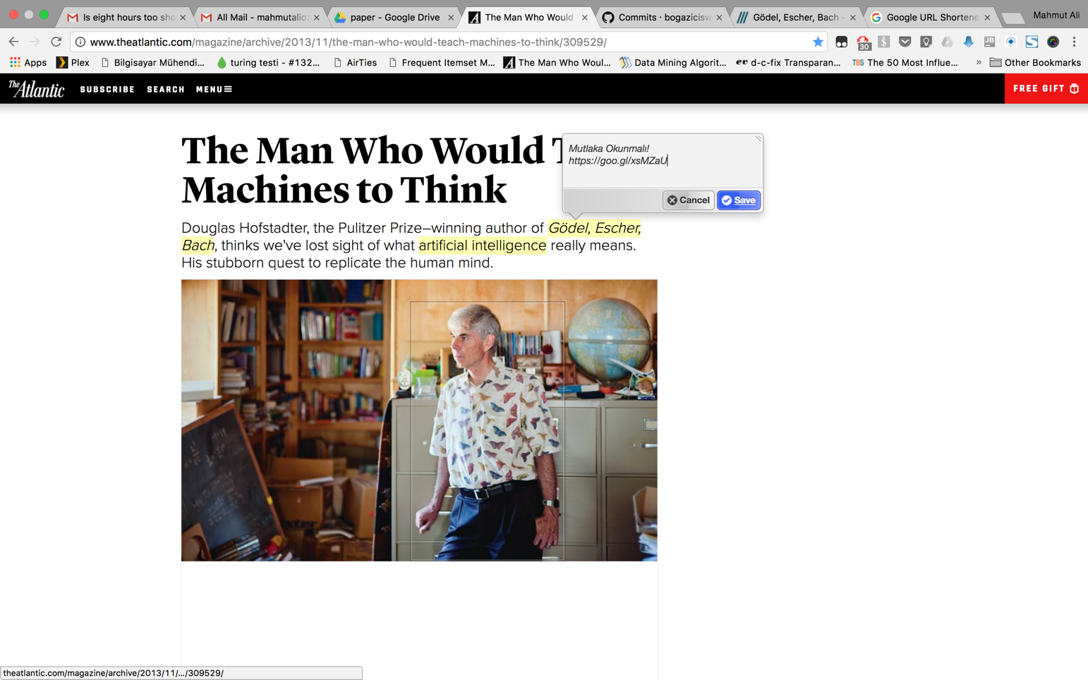

# 

# How to EDIT IMAGE ANNOTATION

Surf to the page the annotation that you want edit is present. Get over the annotation and get annotation to be displayed.

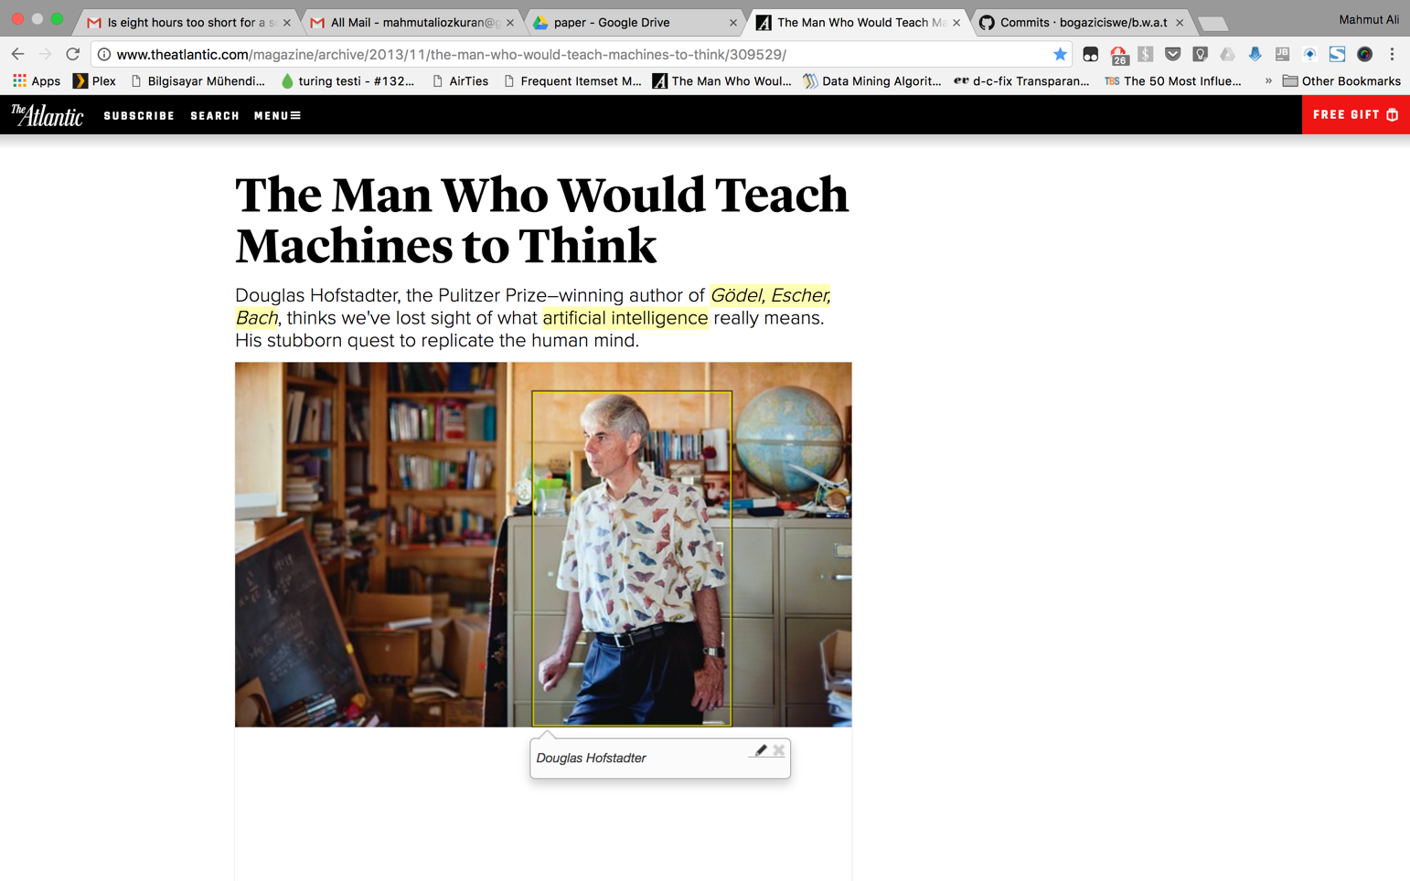

Press the pencil button to edit the annotation. Make your changes and press “Save” button to make your changes permanent.



And your annotation has been edited.

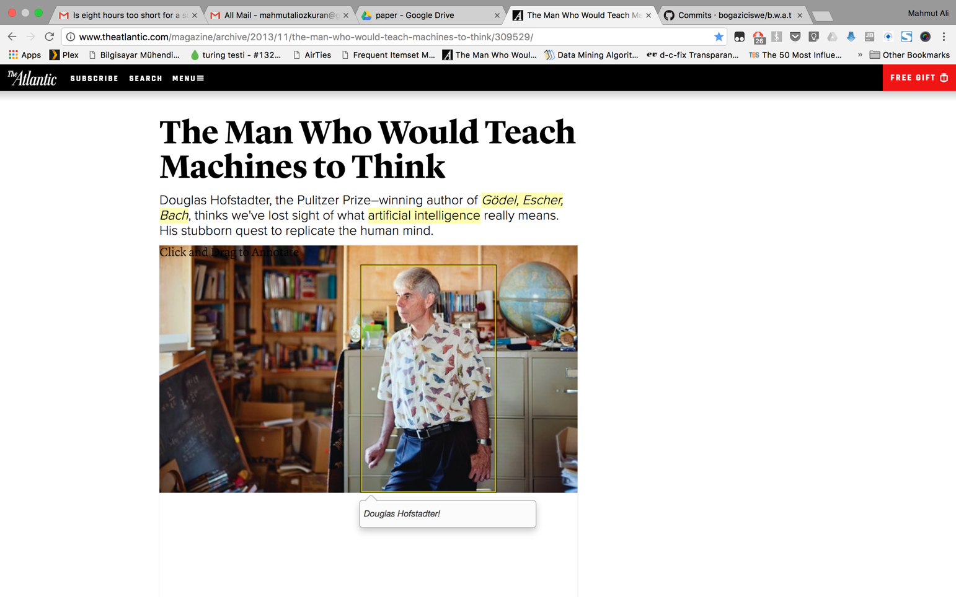

# 

# How to DELETE IMAGE ANNOTATION

Surf to the page the annotation that you want delete is present. Get over the annotation and get annotation to be displayed.



Press the cross button to delete the annotation. Make your changes and press “Save” button to make your changes permanent.

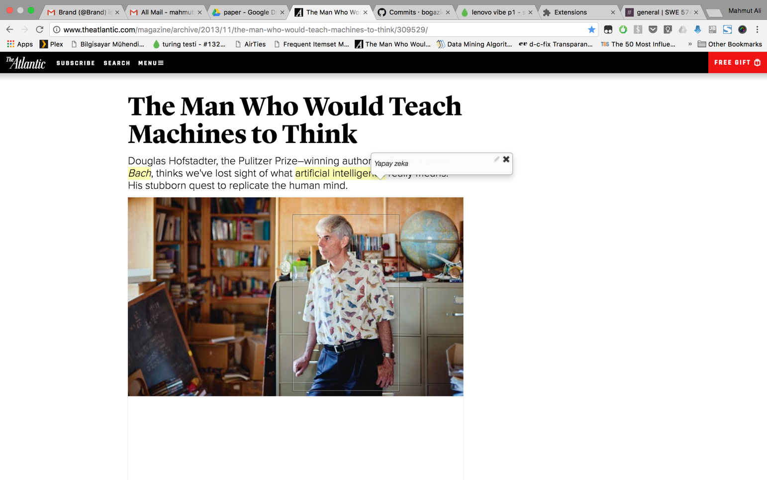

And your annotation has been deleted.



# 